Capstone Project — Part B Project Log
Student Name(s): | Ashraful Islam | Huzaifa Iqbal | Sonu | Dominic Kipchirchir
Student ID(s): | 240135 | 240220 | 250001 | 240401

Project Title: SEDAS — Social Engineering Defence and Awareness System (Implementation of the Part A, MIS5203)
Supervisor: Dr Chandana Withana
Week: 1
Git Repository URL: https://github.com/ailinkon/mis5320-sedas-partb (private; any access will be available on request)

1. Summary of Work Completed
Week 1 delivered the Inception/Elaboration groundwork and the first working component of the SEDAS MVP:
- Specification review: Reviewed and refined the Part A specification: requirements consolidated into numbered form (FR-01..FR-11, NFR-01..NFR-08) and eight formal refinement decisions recorded with justification (see Section 4). Produced two governing documents — the Specification Review & MVP Refinement Memorandum and the Implementation Project Plan (attached).
- Repository establishment: We have established a dedicated private GitHub repository created with a microservice folder layout (services/detection, services/url-verify, services/training, frontend, docs, tests), Python .gitignore, and this cumulative Project Log under version control.
- Detection model (FR-01, NFR-01): Baseline phishing-detection model trained on 82,486 emails from public corpora (Kaggle combined dataset: Nazario, Enron, SpamAssassin, CEAS, Ling, Nigerian) using a TF-IDF (50k features, 1–2 grams) + Logistic Regression pipeline with an 80/20 stratified split. Results on 16,498 held-out emails: Accuracy 0.9859, Precision 0.9867, Recall 0.9862, F1 0.9865 (Part A target ≥ 0.95: MET), false-positive rate 0.0144 (target < 0.02: MET).
- Classification API: /classify REST endpoint implemented in FastAPI exposing the model with explainability returns label, risk score 0–100, top contributing indicators, and measured latency plus a /health endpoint and auto-generated OpenAPI documentation (FR-02, FR-09).
- Automated testing and CI: pytest suite TD-01..TD-05 (health, phishing detection, legitimate pass-through, explainability, latency) — all five passing, each traced to a requirement ID. GitHub Actions CI pipeline runs the suite on every push and pull request.
- Team formation: As per Dr Withana's Week 1 direction, we confirmed our team as Ashraful Islam (240135), Huzaifa Iqbal (240220), Sonu (250001) and Dominic Kipchirchir (240401). We have secured our Consultation slot every Thursdays 11:30am throughout this semester.

2. Evidence of Technical Progress
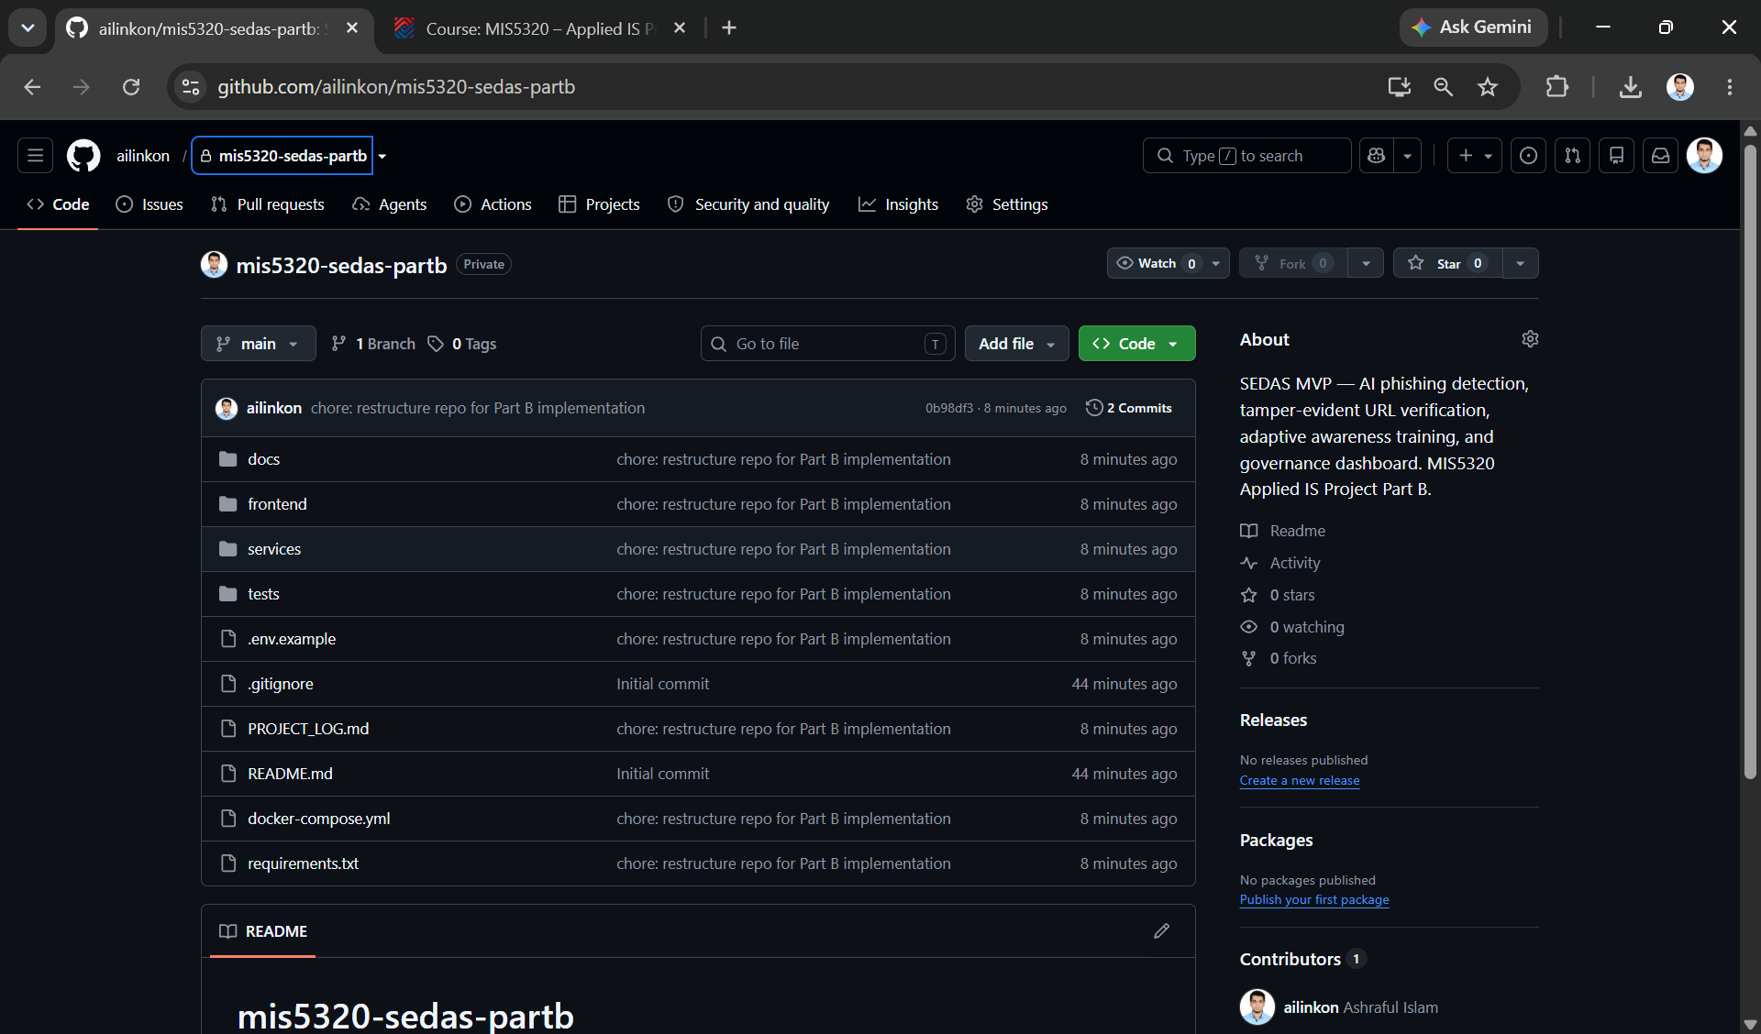
Private Part B repository with microservice structure and 'chore: restructure repo for Part B implementation' commit — establishes version control from day one.
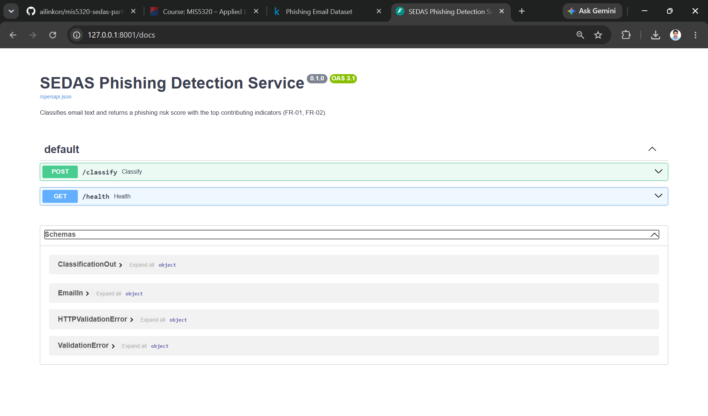
Auto-generated OpenAPI documentation for the SEDAS Phishing Detection Service v0.1.0 — evidences the documented RESTful API requirement (FR-09).
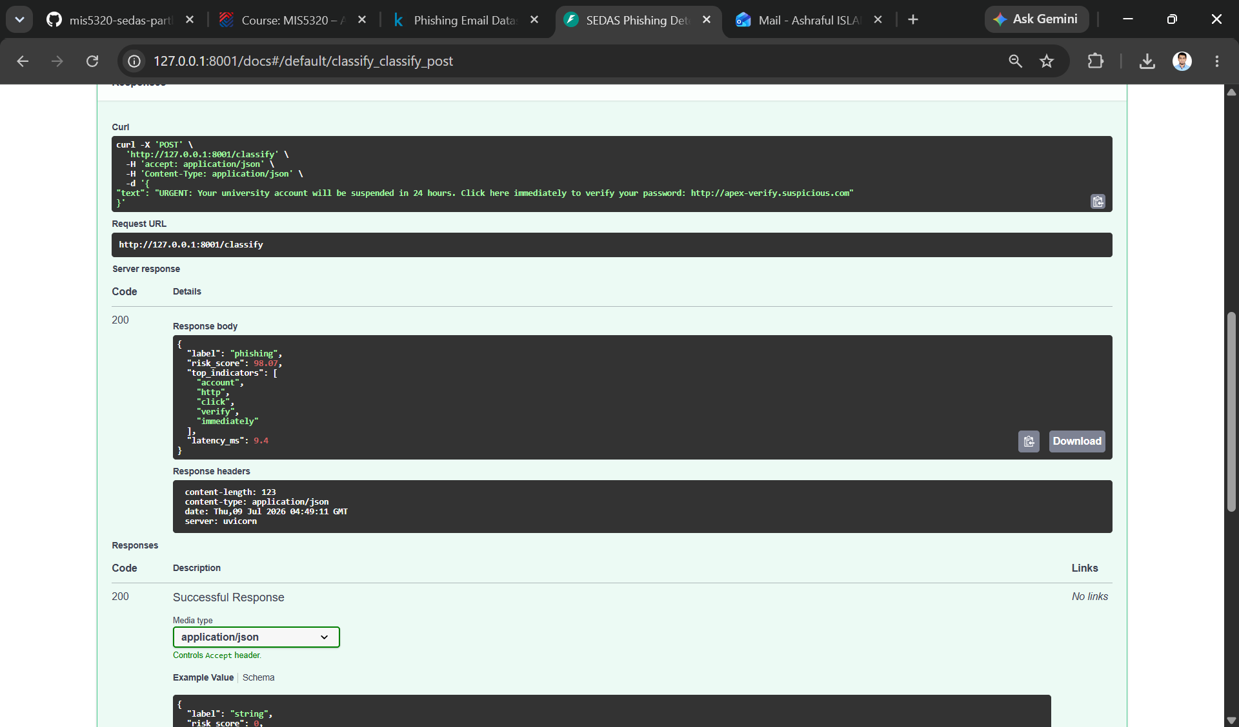
Live classification of a simulated phishing email: 'phishing' at 98.07/100 with explainable indicators (account, http, click, verify, immediately) in 9.4 ms — demonstrates FR-01 and FR-02 working end to end.
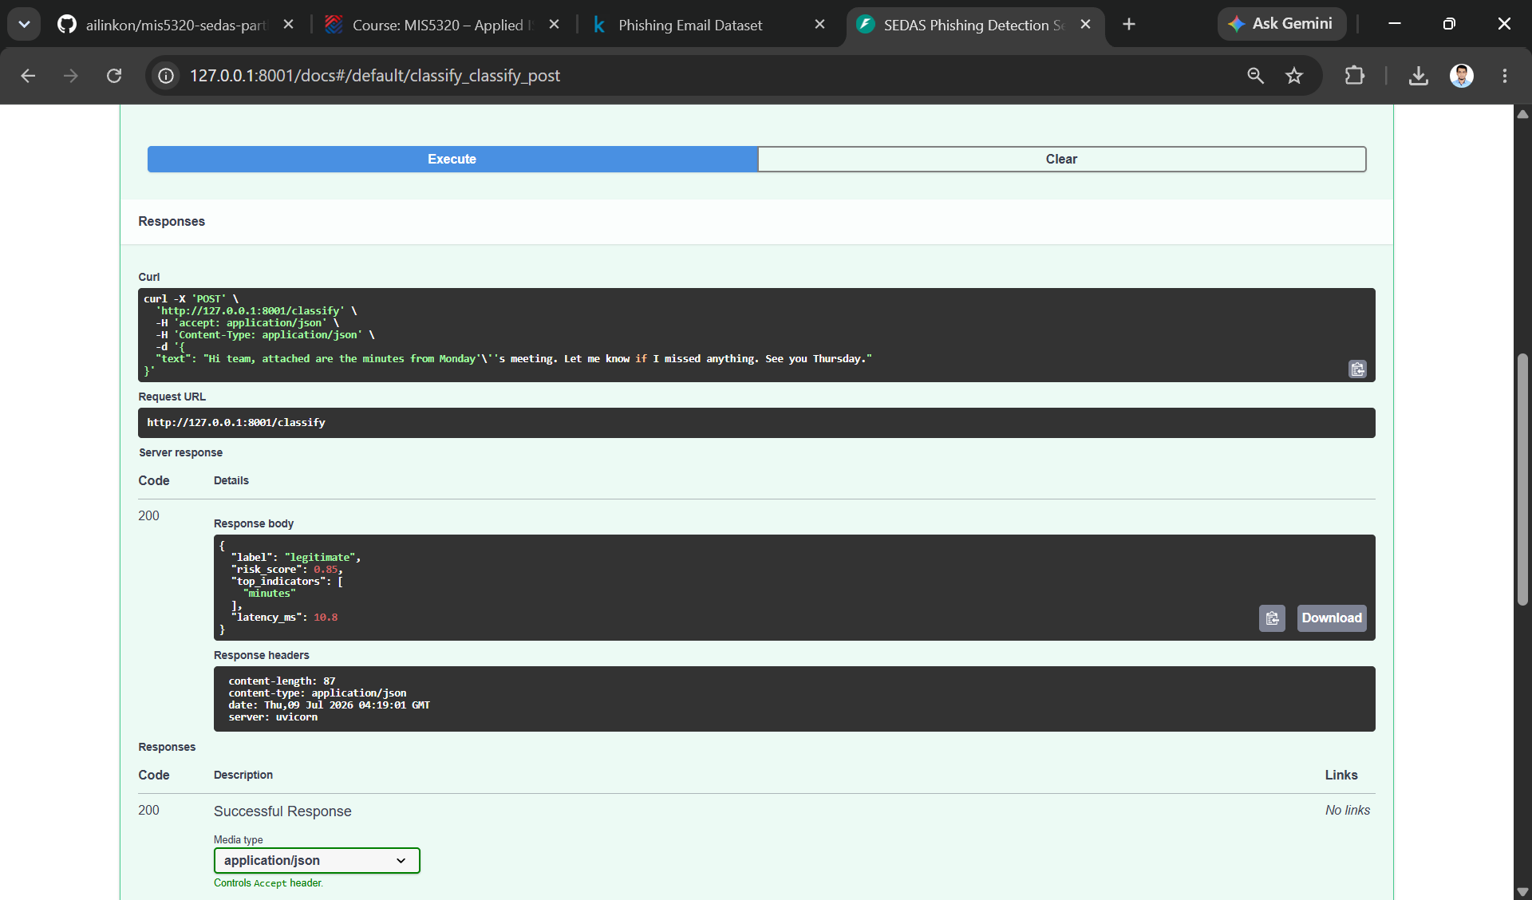
Live classification of a legitimate email: 'legitimate' at 0.85/100 in 10.8 ms — demonstrates low false-positive behaviour consistent with the measured 1.44% FP rate.
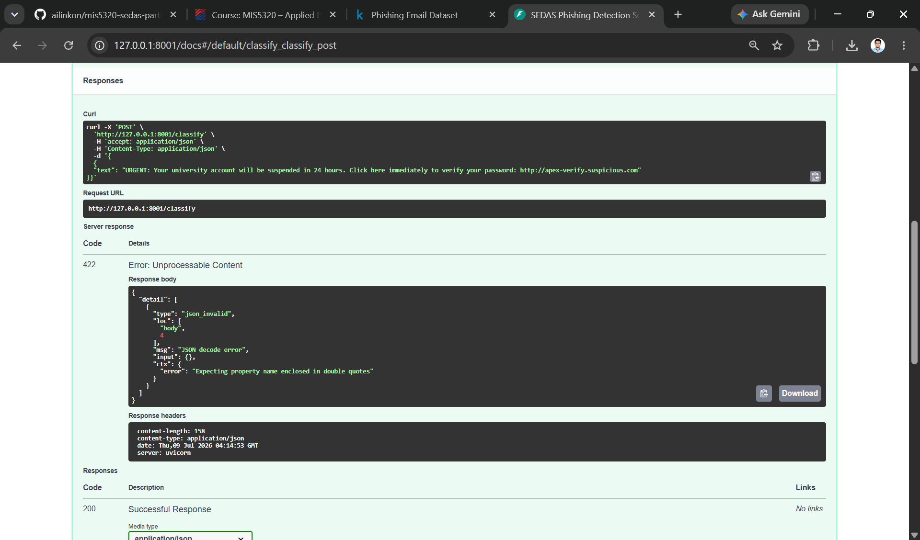
Negative test: malformed JSON correctly rejected with HTTP 422 and a descriptive error — server-side input validation working as designed (NFR-05).
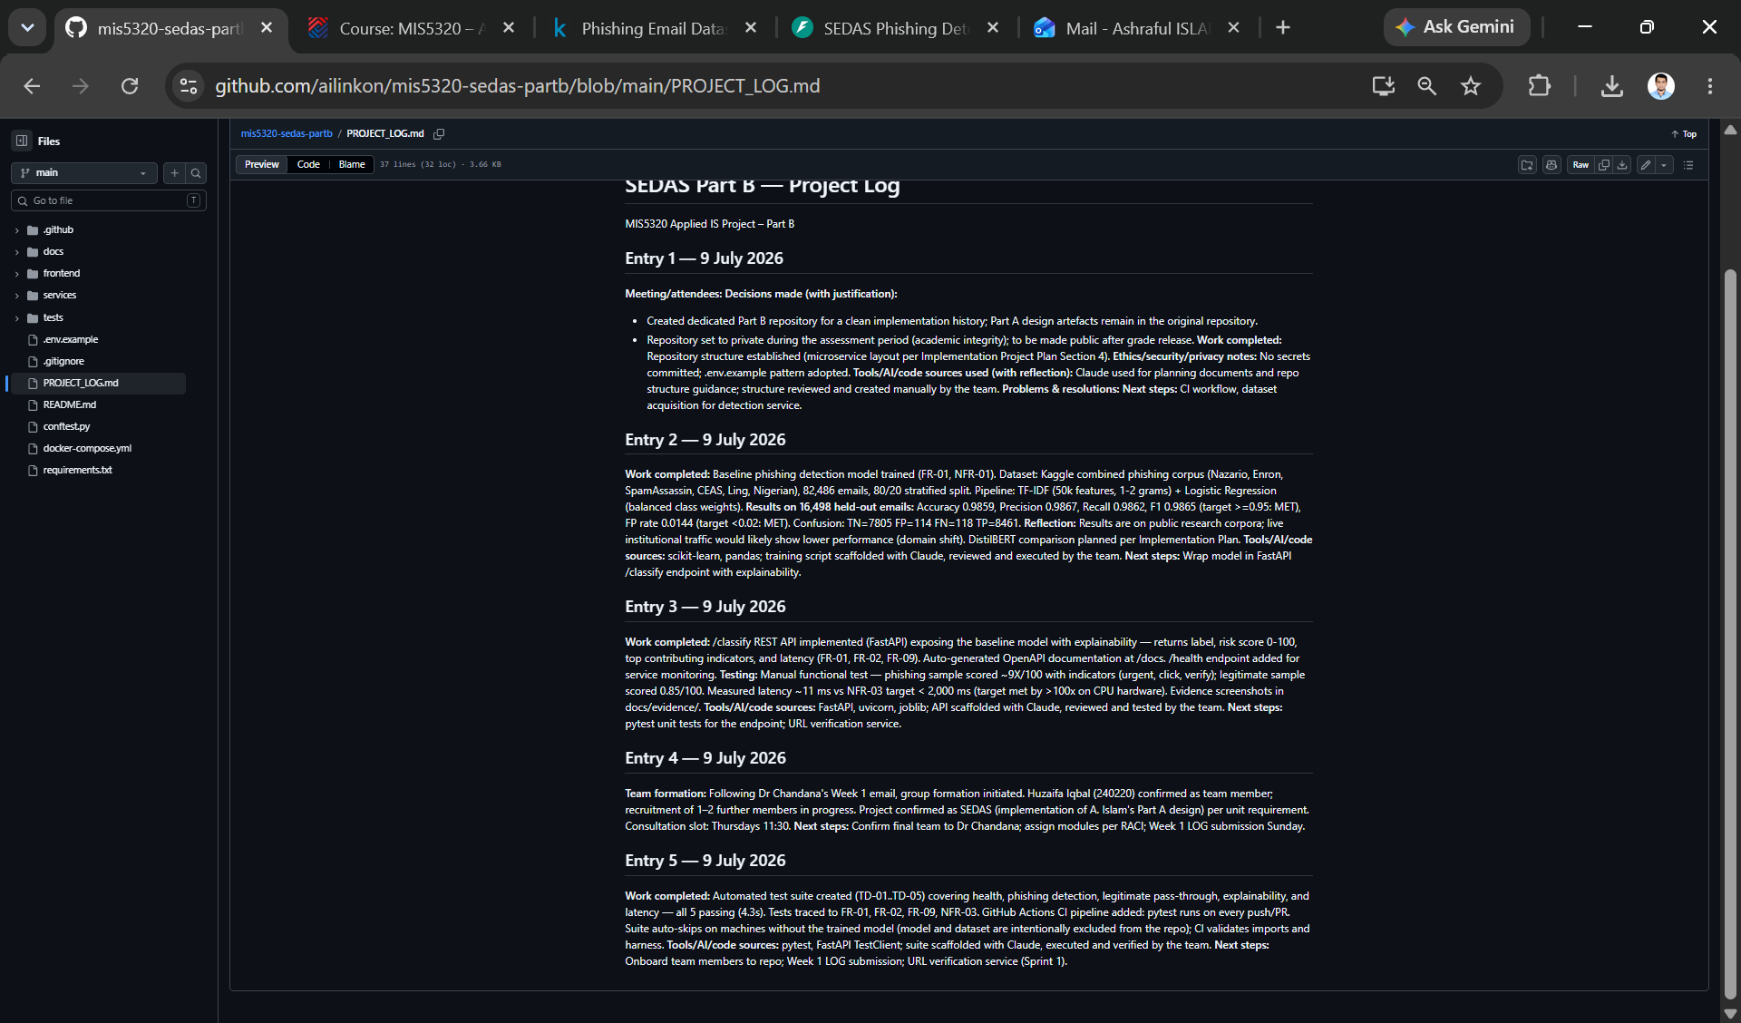
Cumulative time-indexed Project Log maintained in the repository with per-entry decisions, justifications, and AI/tool disclosure.

3. Environment & Infrastructure Setup
- Platform. Windows 11 development workstations; Python 3.14.6 in per-project virtual environments (venv); Visual Studio Code as editor; GitHub Desktop + Git for version control.
- Languages and libraries. FastAPI + uvicorn (API layer), scikit-learn + pandas (ML pipeline), joblib (model persistence), pytest + FastAPI TestClient (testing). Dependencies pinned via requirements.txt for one-command team onboarding.
- Configuration. PowerShell execution policy set to RemoteSigned (CurrentUser scope only — least-privilege choice) to enable venv activation.
- Repository structure. services/detection, services/url-verify, services/training, frontend, docs (incl. docs/evidence), tests — matching the microservice decomposition retained from Part A. Datasets, trained model binaries, virtual environments and secrets are excluded from version control via .gitignore; configuration follows a committed .env.example pattern.
- Continuous integration. GitHub Actions workflow runs the pytest suite on every push/PR. The suite auto-skips on runners without the locally trained model (deliberate: data and binaries stay out of the repo), so CI validates imports and the harness; model-free unit tests will extend coverage.

4. Specification Refinement Outcomes
Following review of the Part A design, the following refinements were recorded in the refinement register (R-01..R-08) and are presented for supervisor sign-off:
- Ethereum smart-contract URL verification descoped to a hash-chained, append-only tamper-evident registry with external reputation lookup — preserves the design intent while removing gas fees, wallet infrastructure and latency risk (R-01).
- Live LMS/SIEM/LDAP-SSO integrations replaced with mock endpoints implementing the documented API contracts, as no institutional access is available to a student team (R-03).
- Latency target re-baselined from < 200 ms (GPU-assumed) to < 2,000 ms on CPU hardware; measured performance (≈ 10 ms) already exceeds both (R-05). Kubernetes/Kafka replaced by Docker Compose while retaining the microservice decomposition (R-06).
- Detection-quality KPI retained (F1 ≥ 0.95) with an honest gap-analysis approach pre-agreed (R-04) — Week 1 results already meet the target on public corpora.
- Ethics re-baseline strengthened for the student build: public/synthetic data only, no real personal information processed, simulated phishing confined to seeded test accounts (APP compliance by design).

5. Issues, Risks & How You Handled Them
- Technical Dimension: Technical dimension: The API test for the initial phishing sample triggered an HTTP 422 error due to duplicate curly braces in the JSON request body. After root cause identification and correction, the classification accuracy reached 98.07%, and this case is retained as negative test evidence for NFR-05 input validation.
- Environment Dimension: PowerShell blocked virtual environment activation. This issue was fixed by applying the least-privilege RemoteSigned execution policy for the current user, without modifying any global configurations, and the decision was fully documented.
- Repository hygiene. Repository specification dimension: The binary file of the first-version trained model was mistakenly added to version control. After adding the relevant file type to.gitignore, only code and documents remain in the repository, and the model can be reproduced via train.py.
- Peer-work: Most trainees had not confirmed their team memberships before the first weekend. This issue was resolved by posting a class team recruitment post, locking in the first team member for unassigned participants, and following up on the Sunday LOG deadline. Potential scale-related risks are managed using a modular RACI matrix.
- Data/validity Check: Models trained on public corpora may suffer performance degradation due to domain shift when processing traffic from real-world organizations. This risk has been recorded, and an additional DistilBERT evaluation is planned. All dimensions adhere to a unified logical framework.

6. Plan for Next Week
- Specification sign-off with supervisor at the Thursday 11:30 consultation; freeze the implementation baseline.
- Allocate modules across the confirmed four-member team per the RACI (frontend/dashboard, awareness training module, URL verification service).
- Onboard members: repository access, environment setup from requirements.txt, teach-back session on the detection service.
- Begin URL verification service: hash-chained tamper-evident registry plus external reputation lookup (FR-03, FR-04, refinement R-01).
- Add model-free unit tests so the CI pipeline exercises real assertions on every push.

7. Supervisor Notes for Signing off (Optional)

